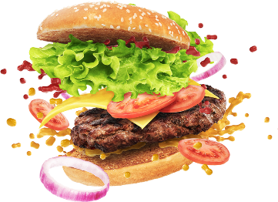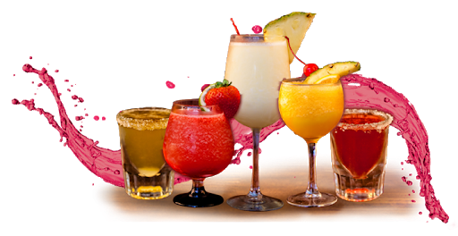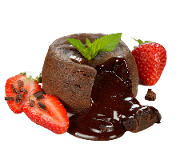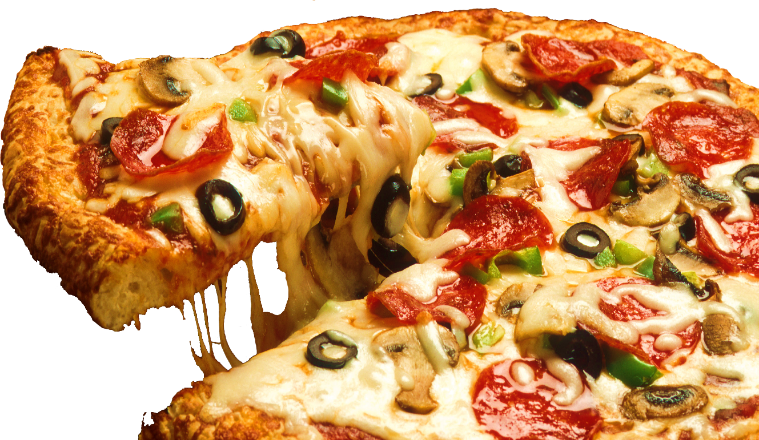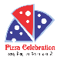

**Party Hall Available For**

**Kitty Party, Birthday Party, Engagement Party, etc...**

**FREE HOME DELIVERY: 8795362000 / 9044715606**

**Add: Kailash Tower Mandenala Pul, Ambedkar Chowraha, Gonda**

**Veg Grilled Sandwich 60/-**

**Pizza Grilled Sandwich 60/-**

**Sweet Corn Grill Sandwich 60/-**

**Makhani Sandwich 60/-**

**Corn Pineapple Sandwich 100/-**

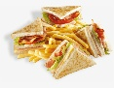

Sandwich



**Contact Us: 8795362000 / 9044715606**

* PizzaCelebrationFood@gmail.com

Our Other Outlet: - NAHAR FAIZABAD  AMBEDKAR NAGAR  AMBEDKAR CHOWRAHA  GONDA

**Sweet Corn Soup 55/-**

**Hot & Sour Soup 60/-**

**Mushroom Soup 85/-**

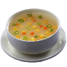

Soups

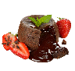

Lava Cake

**Choco Lava 55/-**

**Nutty Choco Lava 75/-**

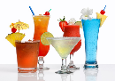

Mocktails

**Green Apple 75/-**

**Mojito Mint 75/-**

**Masala Lemon Tea 55/-**

**Watermelon 55/-**

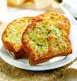

Garlic Breads

**Garlic Bread Six 80/-**

**With Cheese Dip**

**Garlic Bread 80/-**

**With Cheese**

**Garlic Bread 90/-**

**With Cheese Chilli**

**Garlic Bread 90/-**

**With Cheese Jalapenos**

**Stuffed Garlic Bread 115/-**

**Vanilla shake 65/-**

**Kiwi 65/-**

**Mango 65/-**

**Strawberry 65/-**

**Blue Berry 75/-**

**Butter Scotch 75/-**

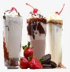

Shakes



Burgers

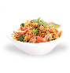

Pasta

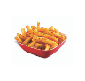

French Fries



Beverages

**Aloo Tikki Burger 45/-**

**Veg Patty Burger 55/-**

**Veg Cheese Burger 80/-**

**Spicy Treat Burger 80/-**

**Maxican Burger 80/-**

**Spicy Paneer Burger 90/-**

**Maharaja Burger 120/-**

**Red Pasta 100/-**

**White Pasta 100/-**

**Luggage Pasta 125/-**

**Mushroom Pasta 125/-**

**Extra Cheese Pasta 135/-**

**French Fries 70/-**

**Masala French Fries 80/-**

**Italian French Fries 80/-**

**Spicy Cheese French Fries 90/-**

**Cold Drink 25/-**

**Black Tea 30/-**

**Coffee 39/-**

**Ice Tea 40/-**

**Cold Coffee 70/-**

**Cold Coffee with 125/-**

**Ice Cream**

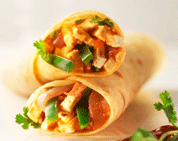

Rolls

**Spring Rolls 69/-**

**Cheese Rolls 80/-**

**Spicy Cheese Rolls 90/-**

**Chilli Paneer Rolls 90/-**

**Makhani Rolls 90/-**

**Butter Scotch 75/-**

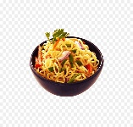

Maggie

**Vegetable Maggie 70/-**

**Dry Maggie 80/-**

**Cheese Chilli Maggie 110/-**

**Schezwan Cheese Maggie 120/-**

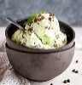

Ice Cream

**Vanilla 40/-**

**Butter Scotch 40/-**

**Chocolate 40/-**

**Strawberry 40/-**

स्वाद ऐसा, जो अपना बना ले